Week 4: Usability Testing Plan – ChatAway

This usability test was performed to test the usability of ChatAway app and identify the issues users might run into, to address them based on feedback and iterate on designs to improve them.

- Target Audience:
- People aged 20-30 years.
- People who use social media apps frequently.
- Testing Size:
- This prototype was testing by 6 users.
- Testing Scenario:
- Task 1: Login to the ChatAway App – Users will login in to the ChatAway app by clicking the login button on the login screen.
- Task 2: Adding a Post – Users will click the “+” button on their story on the home page to add a post.
- Task 3: Selecting an Image from Gallery – Users will select an image from the gallery to post.
- Task 4: Pressing Continue – Users will click continue on top right side to post the image.
- Task 4: View Profile – Users will then be moved to their user profile screen where they can see their previous posts and their information.
- Task 5: Edit Profile – Users will then click on the edit profile icon to move to the settings screen.
- Task 6: Moving to the Settings Screen – From the settings screen they can explore multiple options.
- Task 7: Logging out the ChatAway app – From the settings screen they can logout the app by clicking “logout”.
- Tool Used:
- I used “Maze” to test usability.
- Analyzing Feedback:
Screen | Issue | Feedback
Post Creation | The posted image wasn’t visible on user profile after continue. | Confused 1 user.
User Profile | Edit profile screen wasn’t available. | 1 user raised this concern.
Settings | Dark Mode wasn’t available. | I identified this flaw.

- Findings:
- The image being selected in the gallery to post should be added to the user file in the recent post after clicking continue from post creation screen and moving on to user profile, so it is visible that it was posted.
- Edit profile screen is missing, which should be created to not confuse the user.
- Dark mode toggle button should be added in the settings.
- Improvements:
- The image selection from gallery to post is now added in the user profile as recent post.

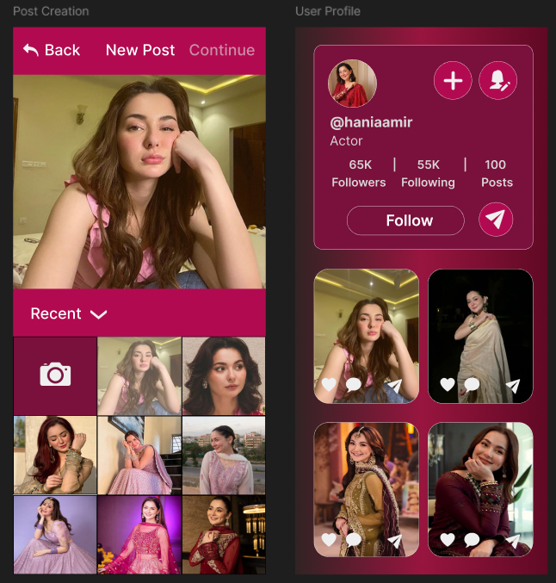

- Edit profile screen is added.
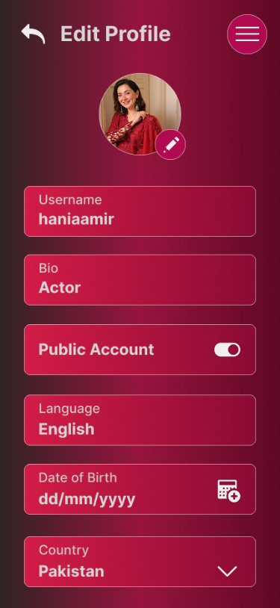
- Dark Mode option is added.
